Task 01:

|  |  |  |  |  |
| --- | --- | --- | --- | --- |
| Switch | S | R | Q | Q’ |
|  |  |  |  |  |
| 0 | 0 | 0 | In All it show last active input is called  Memory Condition | |
| 0 | 0 | 1 |
| 0 | 1 | 0 |
| 0 | 1 | 1 |
| 1 | 0 | 0 | 1 | 1 |
| 1 | 0 | 1 | 1 | 0 |
| 1 | 1 | 0 | 0 | 1 |
| 1 | 1 | 1 | 1(N0 Change) | 1(Is Called Memory Codition) |

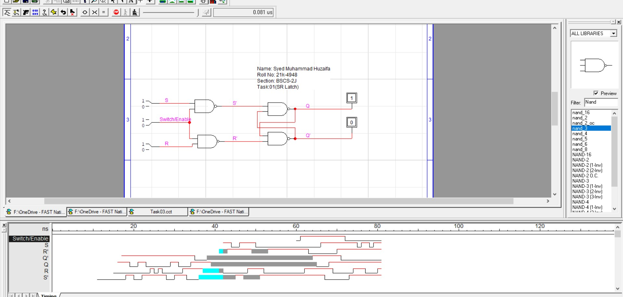

Task 02:

|  |  |  |  |  |
| --- | --- | --- | --- | --- |
| Clock | Input 1 | Input 2 | Q | Q’ |
|  |  |  |  |  |
| 0 | 0 | 0 | In All it show last active input is called  Memory Condition | |
| 0 | 0 | 1 |
| 0 | 1 | 0 |
| 0 | 1 | 1 |
| 1 | 0 | 0 | 1 | 1 |
| 1 | 0 | 1 | 1 | 0 |
| 1 | 1 | 0 | 0 | 1 |
| 1 | 1 | 1 | 1(N0 Change) | 1(Is Called Memory Codition) |

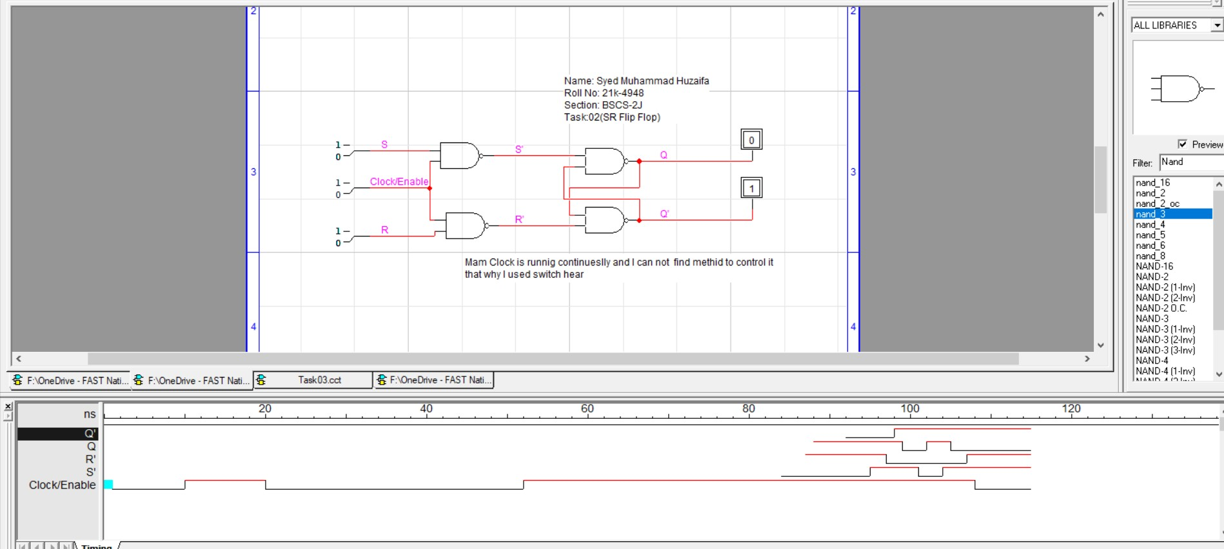

Task 03:

|  |  |  |  |  |  |
| --- | --- | --- | --- | --- | --- |
| Clock | D | S | R | Q | Q’ |
|  |  |  |  |  |  |
| 0 | 0 | 0 | 1 | In All it show last active input is called  Memory Condition | |
| 0 | 1 | 1 | 0 |
| 1 | 0 | 0 | 1 | 1 | 0 |
| 1 | 1 | 1 | 0 | 0 | 1 |

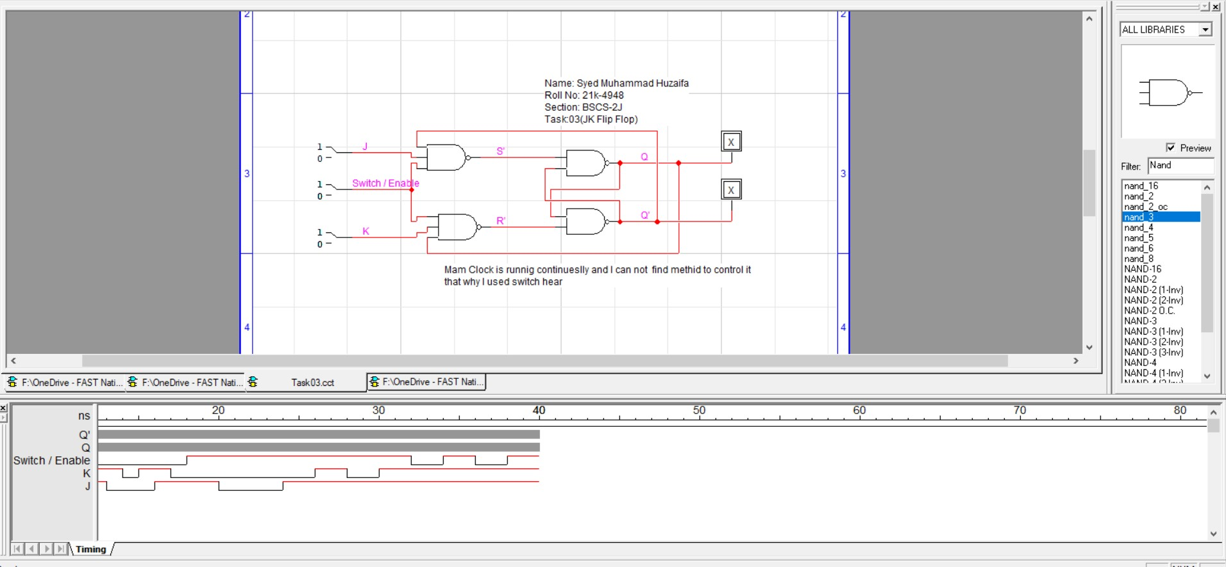

Task 04:

|  |  |  |  |  |
| --- | --- | --- | --- | --- |
| Clock | J | K | Q | Q’ |
|  |  |  |  |  |
| 0 | 0 | 0 | In this Circuit is not running and  In thsi Privious output is saved this  Is called memory condition | |
| 0 | 0 | 1 |
| 0 | 1 | 0 |
| 0 | 1 | 1 |
| 1 | 0 | 0 | Privious Input | |
| 1 | 0 | 1 | 0 |  |
| 1 | 1 | 0 | 1 |  |
| 1 | 1 | 1 | Toggle (0 to 1 or 1 to 0) | Toggle (0 to 1 or 1 to 0) |

